

Lab 1- bit.ly/3SsNbj4

| Name | Margaretha Aprilliana Satriadi |
| --- | --- |
| Date | 22nd January 2025 |
| Student No | S00265097 |
| Student Email | S00265097@atu.ie |

### **GitHub**

1. Make a copy of this document on Google Docs
2. Go to <http://github.com>
3. Sign up for a GitHub Account (make sure to use your ATU Sligo student email address when you signup as this will entitle you to a free Student that includes 5 free private repositories.)
4. Enter your GitHub username here and also enter it into this [form](https://forms.gle/2WXr81guCMnnAb989):

| MargarethaSatriadi |
| --- |

1. Once your account has been setup, try creating a new Repository called **firstrepo** using the Add Repository button below your profile picture.
2. Use the Add File button to add a new file to your repository, give your new file a name, type some text and save the file.

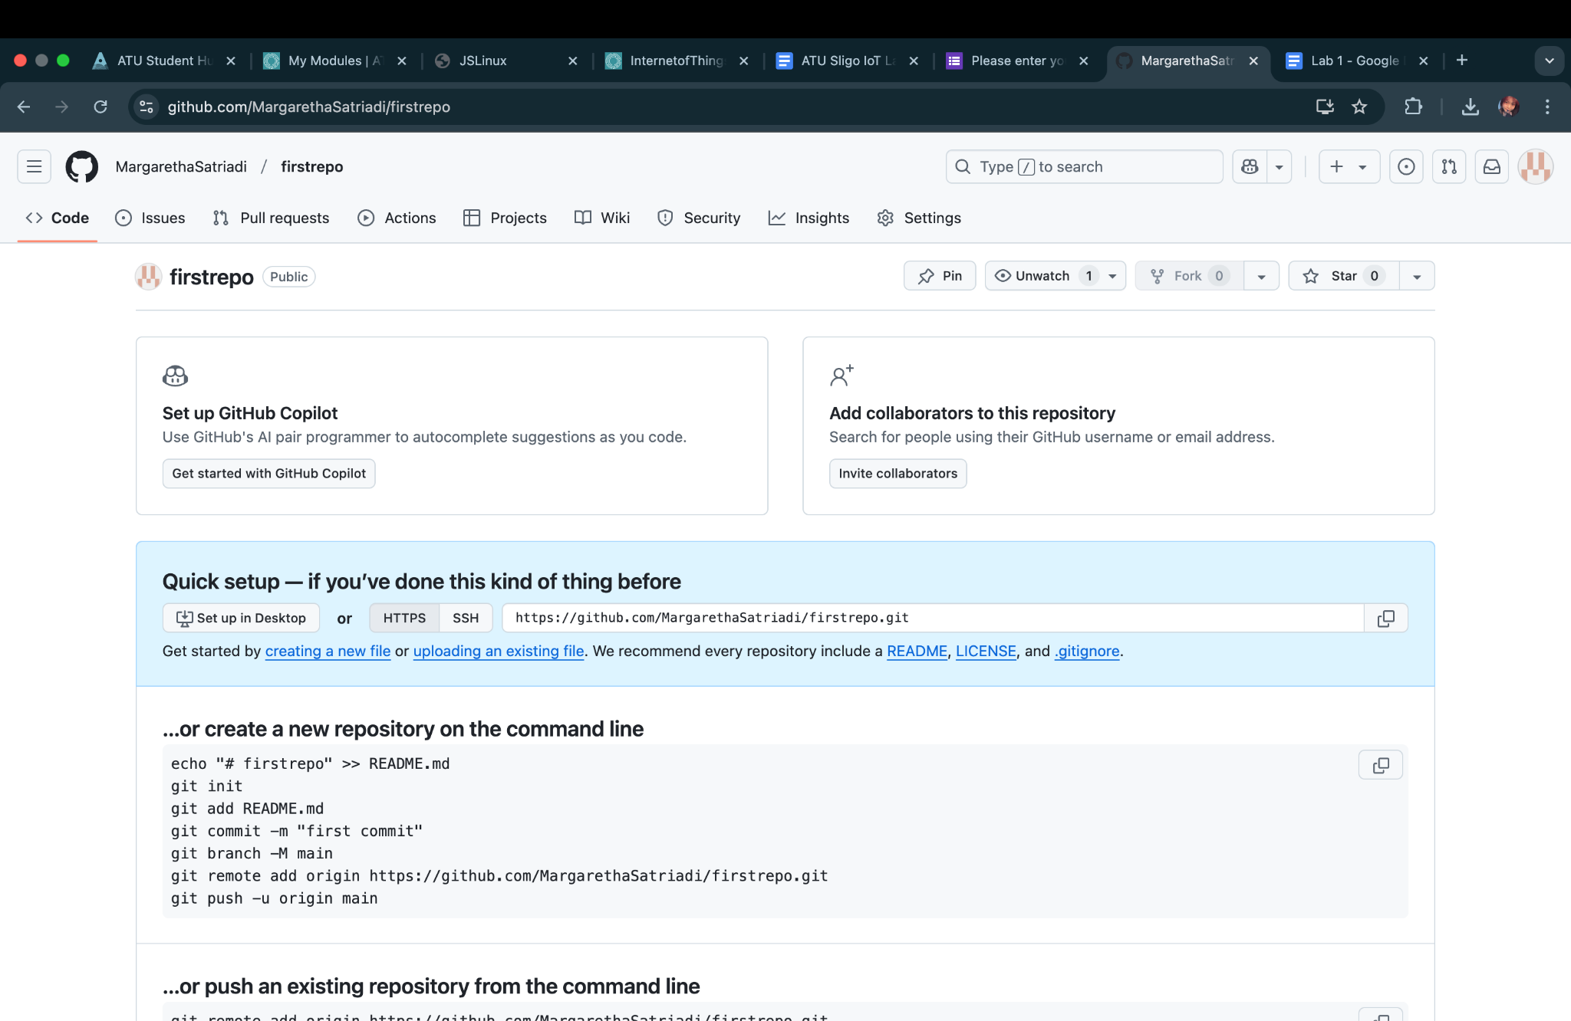

### **Arduino IDE & Coding Basics**

1. Find the Blink tutorial on the Arduino Website

<https://www.arduino.cc/en/Tutorial/BuiltInExamples/Blink>

1. Open the Blink Sketch in the Wokwi emulator here: <https://bit.ly/3S8HxS6>:   
     
   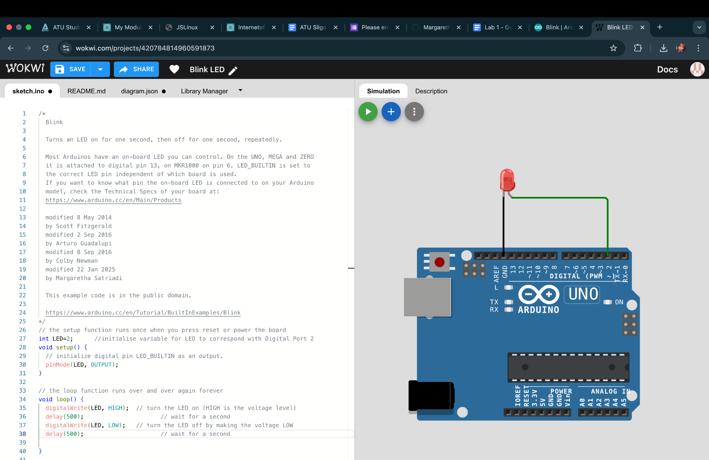
2. Change the blink delay values to 500 - what will be the effect of this change?

| The LED light blinks faster then before |
| --- |

1. Add a ‘modified by’ line to the sketch comment at the top, with your name and date and paste a screen shot replacing this one:  
   
2. Upload your version of Blink to your GitHub account and provide the link here:

| [Blink Link](https://github.com/MargarethaSatriadi/firstrepo/commit/061774ae8cf6219adccdca1396cad88b221ee40a) |
| --- |

1. Paste a screenshot here of your code uploaded to GitHub  
   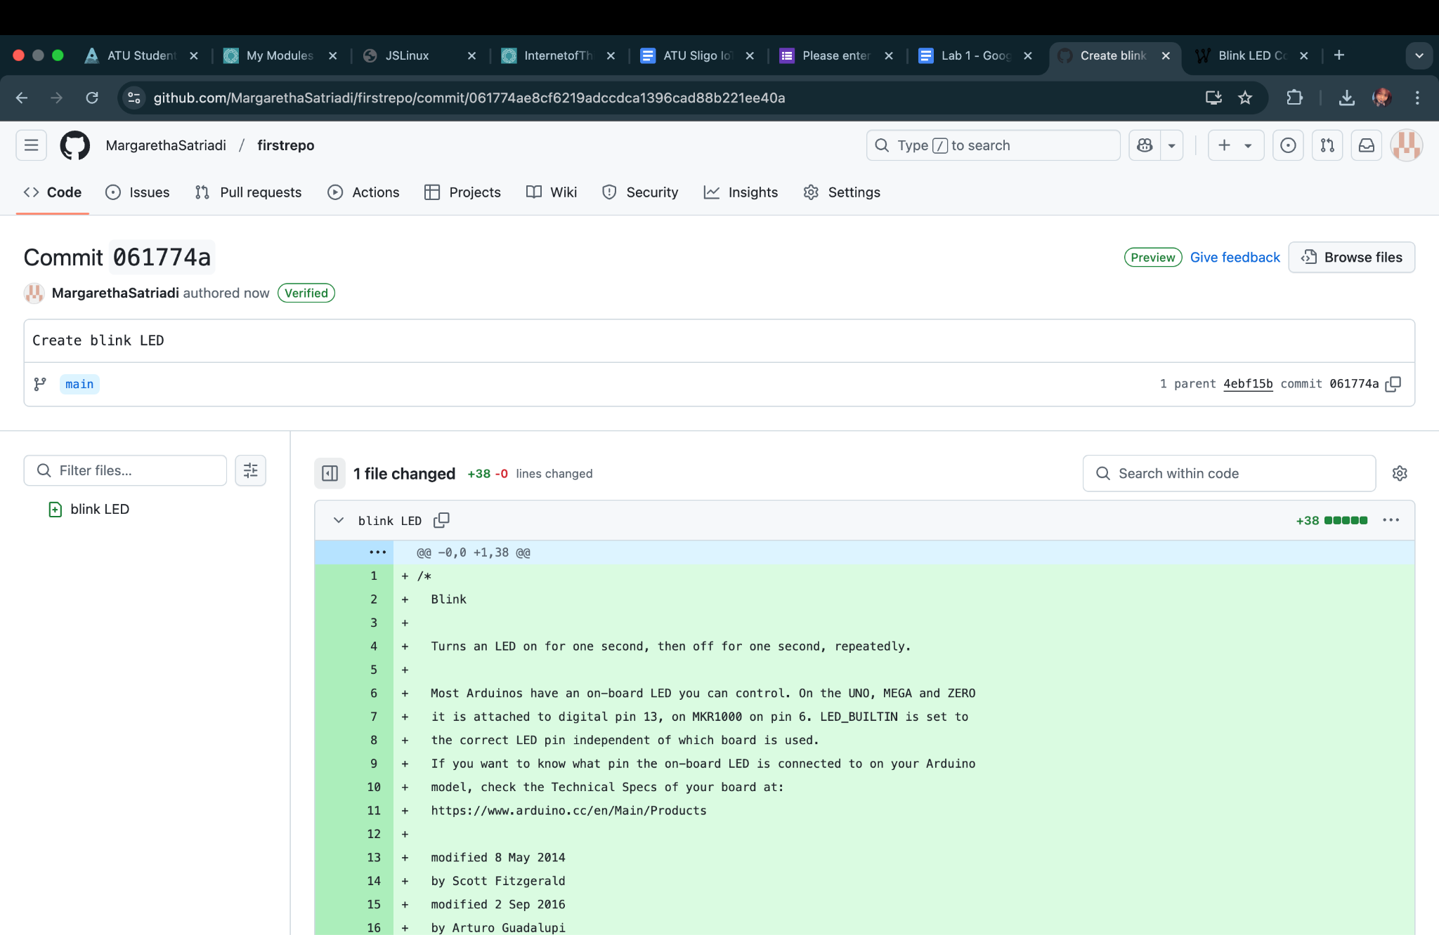
2. ***Upload your Lab to Moodle!***